**Project Design Phase-I**

**Solution Architecture**

|  |  |
| --- | --- |
| Date | 18 October 2022 |
| Team ID | PNT2022TMID47261 |
| Project Name | Project – Plasma Donor Application Using Cloud Computing |
| Maximum Marks | 4 Marks |

**Solution Architecture:**

Algorithm Plasma bank

 Problem Description: This Algorithm computes plasma bank application.

 Input: I, P are the of character type.

 Output: Outcome is Notification and Response from plasma bank for plasma.

 Step 1: If User is registered then provide User Id (I) and password (P) else Create new account;

 Step 2: While plasma stock gets low Send notification to donors for plasma donation camp;

 Step 3: If there is request from user for plasma, track location of user with GPS;

 Step 4: Check for plasma availability at plasma bank;

 Step 5: If plasma is not available send notification from plasma bank to nearby registered Donors;

 Step 6: Check conditions for plasma donation like HB, Weight, other factors and previous history;

 Step 7: If conditions are satisfied accept it;

 Step 8: If Conditions are not satisfied then send notification to other donors who are eligible;

**Solution Architecture Diagram:**

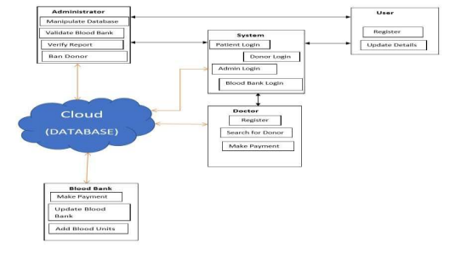

**Reference**

Lifesaver E-PlasmaDonation App Using Cloud Rishab Chakrabarti1, Asha Darade2, Neha Jadhav3, Prof. S. M. Chitalkar4

1,2,3,4Department of Computer Engineering, Sinhgad Institute of Technology and Science, India